# Project Development Phase

**Delivery of Sprint - 2**

|  |  |
| --- | --- |
| **Date** | 19 NOVEMBER 2022 |
| **Team ID** | PNT2022TMID27784 |
| **Project Name** | AI-based discourse for Banking Industry |

# Creating Saving Account Action

Create a saving account in IBM Watson. Create new **Action** Saving.

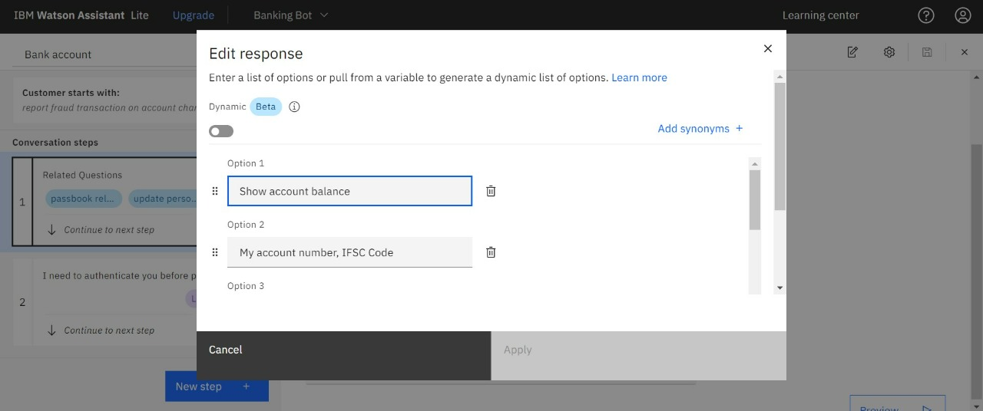

Add steps in savings action.

**Creating Current Account Action**

Create a new **Action** Current for the current account action.

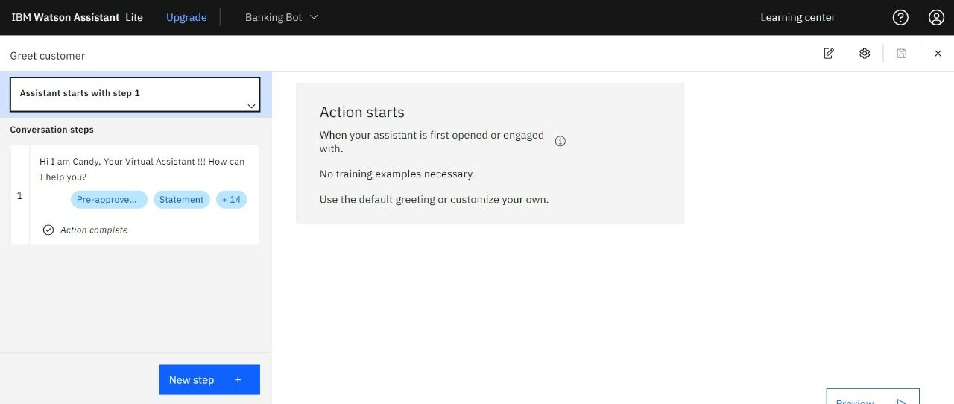

Add steps in savings action.

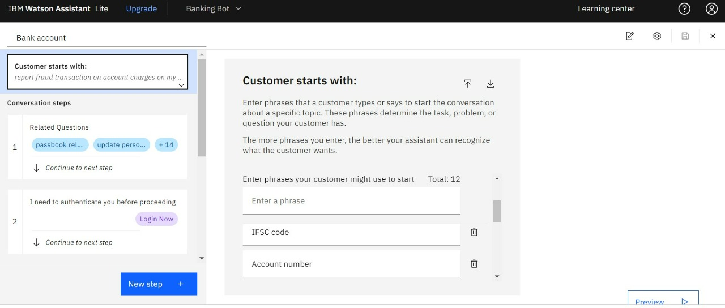

**Note:** No code for this project. So, I attached the screenshot and step to build it.